gowthamrofficials@gmail.com

**Analysis and Performance evaluation of Terapixel rendering in (Super)Cloud Computing Data**

**220403421**

**Gowdham Ramesh**

1. **Introduction**

The purpose of this study is to analyze the IoT environmental data collected by Newcastle Urban Observatory for the city of Newcastle Upon Tyne. The main objective is to evaluate and explore performance timings of render application and GPU card and in each task, the details of which part of the image was being rendered. Terapixel images are rendered using a scalable cloud-based visualization architecture. The Terapixel image, once created, allows for interactive exploration of the city and its data at a wide range of sensing scales ranging from the entire city to a separate desk in a room, and is accessible via a broad range of thin client devices. **CRISP-DM** (Cross- Industry Standard Process for Data Mining) model will be used in this data analysis. This project will be entirely dedicated to the **EDA** (Exploratory Data Analysis) process.

CRISP-DM Methodology to be followed:

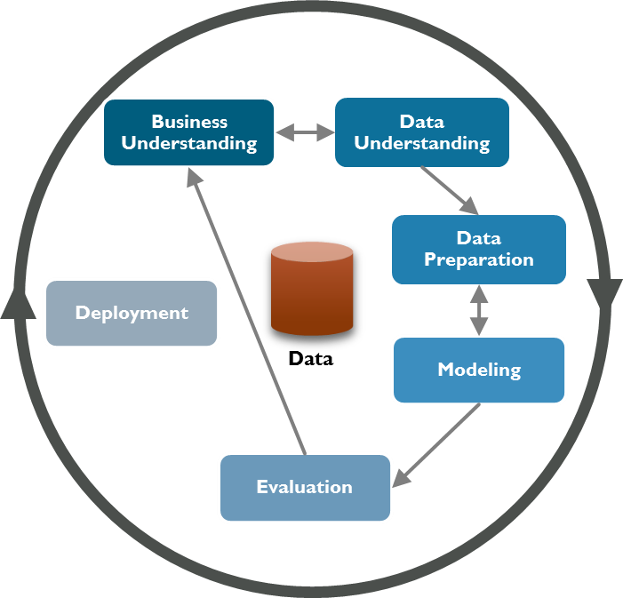

Fig 1

1. **Data Exploration Planning and Analysis Requirement:**

Tera scope terapixel data is subjected to preliminary analysis to better understand the data and provide information to business stakeholders. Based on the data set, this analysis of GPU cards and XY coordinates will aid in rendering Terapixel images in an efficient and effective manner.

* 1. **Data Exploration Planning:**
* Assessing the event types that dominate task runtimes.
* Discovering the relationship between GPU metrics.
* Identification of serial numbers of GPU with least performance.
* Interplay between GPU Temperature and Power Consumption.
* Variation in Memory Utilization Percentage of the GPU with GPU Temperature.
* Event Runtime for each co-ordinate of the Rendered Tile for level 8.
  1. **Analysis Plan and Requirement:**

The analysis strategy for this report is to investigate the three data sets generated while different virtual machines render 3D images on 1024 GPU nodes during a run. This run is divided into three jobs to render the data visualization output, which show performance timing of the render application, performance of the GPU card, and details of which part of the image was rendered in each task. The requisite is to understand the data, then clean and preprocess the data before performing exploratory data analysis. This analysis will aid in the betterment of the rendering process.

* 1. **Resources:**
* Data sets ***application-checkpoint.csv, gpu.csv, task-x-y.csv***.
* Jupyter Notebook
* GitHub
* Microsoft Word
  1. **Impediment (Constraints):**
* There could be insufficient accurate data to draw a convincing conclusion.
* The Timeframe in the datasets *gpu.csv* and *application checkpoints.csv* file varies slightly.
* Duplicate data in the data set may taint the outcome.
* The negative aspect of this analysis is the poor data quality.

1. **Data Understanding:**
   1. **Data Gathering and Description:**

This analysis utilizes data from a dataset generated during a run with 1024 nodes. This analysis will be performed using three csv files *application-checkpoints.csv, gpu.csv, task-x-y.csv.* Below is the first three sets of data from the tables.

Table **application-checkpoints.csv:**

|  |  |  |  |  |  |
| --- | --- | --- | --- | --- | --- |
| timestamp | hostname | eventName | eventType | jobId | taskId |
| 2018-11-08T07:41:55.921Z | 0d56a730076643d585f77e00d2d8521a00000N | Tiling | STOP | 1024-lvl12-7e026be3-5fd0-48ee-b7d1-abd61f747705 | b47f0263-ba1c-48a7-8d29-4bf021b72043 |
| 2018-11-08T07:42:29.842Z | 0d56a730076643d585f77e00d2d8521a00000N | Saving Config | START | 1024-lvl12-7e026be3-5fd0-48ee-b7d1-abd61f747705 | 20fb9fcf-a927-4a4b-a64c-70258b66b42d |
| 2018-11-08T07:42:29.845Z | 0d56a730076643d585f77e00d2d8521a00000N | Saving Config | STOP | 1024-lvl12-7e026be3-5fd0-48ee-b7d1-abd61f747705 | 20fb9fcf-a927-4a4b-a64c-70258b66b42d |

* **timestamp** - Event start and stop time
* **hostname** - The virtual computer's hostname
* **eventName** - The name of the event that is taking place within the visualisation application.
* **TotalRender -** is the entire task
* **Render -** is when the image tile is being rendered
* **Saving Config** - It’s just a metric for configuration overhead.
* **Tiling** - is where post processing of the rendered tile is taking place
* **Uploading -** is where the output from post processing is uploaded to Azure Blob Storage
* **eventType** – Start and Stop of the events.
* **jobID** – ID of the Azure batch job.
* **taskID** - The Azure batch task's identification number.

Table **gpu.csv:**

|  |  |  |  |  |  |  |  |
| --- | --- | --- | --- | --- | --- | --- | --- |
| timestamp | Hostname | gpuSerial | gpuUUID | powerDrawWatt | gpuTempC | gpuUtilPerc | gpuMemUtilPerc |
| 2018-11-08T08:27:10.314Z | 8b6a0eebc87b4cb2b0539e81075191b900001C | 3.23217E+11 | GPU-1d1602dc-f615-a7c7-ab53-fb4a7a479534 | 131.55 | 48 | 92 | 53 |
| 2018-11-08T08:27:10.192Z | d8241877cd994572b46c861e5d144c85000000 | 3.23617E+11 | GPU-04a2dea7-f4f1-12d0-b94d-996446746e6f | 117.03 | 40 | 92 | 48 |
| 2018-11-08T08:27:10.842Z | db871cd77a544e13bc791a64a0c8ed50000006 | 3.23217E+11 | GPU-f4597939-a0b4-e78a-2436-12dbab9a350f | 121.64 | 45 | 91 | 44 |

* **gpuSerial -** The physical GPU card's serial number.
* **gpuUUID -** The unique system id assigned to the GPU unit by the Azure system.
* **powerDrawWatt -** The GPU's power consumption in watts.
* **gpuTempC -** GPU temperature in degrees Celsius.
* **gpuUtilPerc -** % utilization of the GPU Core (s).
* **gpuMemUtilPerc -** The percentage of GPU memory used.

Table **task-x-y.csv:**

|  |  |  |  |  |
| --- | --- | --- | --- | --- |
| taskId | jobId | x | Y | level |
| 00004e77-304c-4fbd-88a1-1346ef947567 | 1024-lvl12-7e026be3-5fd0-48ee-b7d1-abd61f747705 | 116 | 178 | 12 |
| 0002afb5-d05e-4da9-bd53-7b6dc19ea6d4 | 1024-lvl12-7e026be3-5fd0-48ee-b7d1-abd61f747705 | 142 | 190 | 12 |
| 0003c380-4db9-49fb-8e1c-6f8ae466ad85 | 1024-lvl12-7e026be3-5fd0-48ee-b7d1-abd61f747705 | 142 | 86 | 12 |

* **x -** The X co-ordinate of the image tile.
* **y -** The Y co-ordinate of the image tile.
* **level –** Zoomable level.

1. **Data Preparation:**

Following Data Understanding, the data is cleaned, the necessary datatypes are changed, and the data is preprocessed in preparation for further data analysis.

* 1. **Data Pre-processing:**
* All three csv files are read: **application-checkpoints.csv, gpu.csv,** and **task-x-y.csv.**

**4.1.1 Data Cleaning:**

* It is observed that all the three datasets contain no null values.
* The total number of duplicate records observed in the appcheckpoint, gpu, and xy tables is 2470,9, and 0.
* As part of data cleaning, duplicate records are removed from all three tables.

Below are the tables after data Cleaning:

Table appcheck

gpufinal

xyfinal

**4.1.2 Preprocessing:**

* To ensure clarity, the Time Stamp format in appcheckand gpu is changed from object to DateTime64.

Appcheck data frame datatype gpufinal data frame datatype

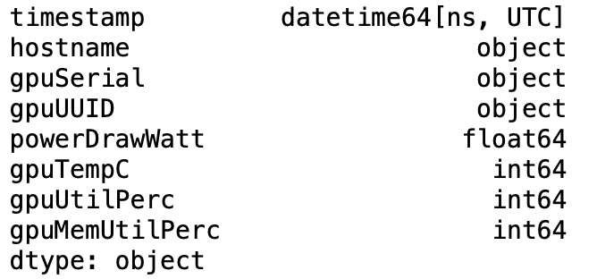

* The gpuSerial column in the gpufinal table is converted from numeric to object format in order to perform additional analysis.
* The start and stop times is calculated by using the eventType from appcheck table.

Below table shows the start and stop time calculated and displayed for last four rows of appcheck data frame:

* Event Render Time is calculated based on the variation between start and stop EventType times.

Below table shows the Event Render Time computed:

* For further interpretation, Event Render Time of appcheck table is sorted by Hostname.

First Three Rows of table based on hostname and Event Render Time is displayed:

|  |  |
| --- | --- |
| **hostname** | **Event_RenderTime** |
| 04dc4e9647154250beeee51b866b0715000000 | 44.350327 |
| 04dc4e9647154250beeee51b866b0715000001 | 45.698051 |
| 04dc4e9647154250beeee51b866b0715000002 | 40.275421 |

* Grouping gpufinal table based on hostname and other performance parameters:

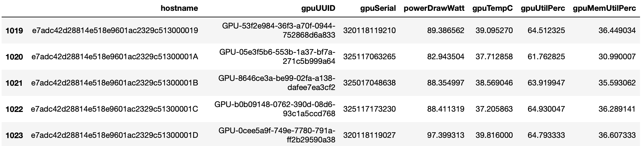

* A TP data frame is created by combining host PT and gpu PF based on the hostname.

TP dataframe:

* xyfinal1 is made by combining xyfinal and appcheck_start_stop on the basis of Total Render (Entire task).
* The xy_level8 data frame is created for the level 8 image by grouping Event Render Time by x and y coordinates.

|  |  |  |
| --- | --- | --- |
| **x** | **y** | **Event_RenderTime** |
| 0 | 0 | 43.853001 |
| 0 | 1 | 24.809999 |
| 0 | 2 | 27.111000 |
| 0 | 3 | 35.481998 |
| 0 | 4 | 43.898998 |

* The Level RT table is created for calculating Average Event Render Time for the level 4, 8, and 12.

|  |  |
| --- | --- |
| **level** | **Event_RenderTime** |
| 4 | 52.181999 |
| 8 | 48.45982 |
| 12 | 42.58176 |

The tables listed above will be used for additional data analysis.

1. **Exploratory Data Analysis:**

Exploratory Data Analysis is used to analyze data and envision models on Terapixel preprocessed data. This analysis will help to improve the image rendering process.

* 1. **Data Exploration:**

Data is explored based on the below scenarios

* + 1. **Assessing the event types that dominate task runtimes:**

There are five events occurring within the visualization process:

* **Total Render -** is the entire task
* **Render -** is when the image tile is being rendered
* **Saving Config** - It’s just a metric for configuration overhead.
* **Tiling** - is where post processing of the rendered tile is taking place
* **Uploading -** is where the output from post processing is uploaded to Azure Blob Storage

The table below shows the average time taken by all events in seconds:

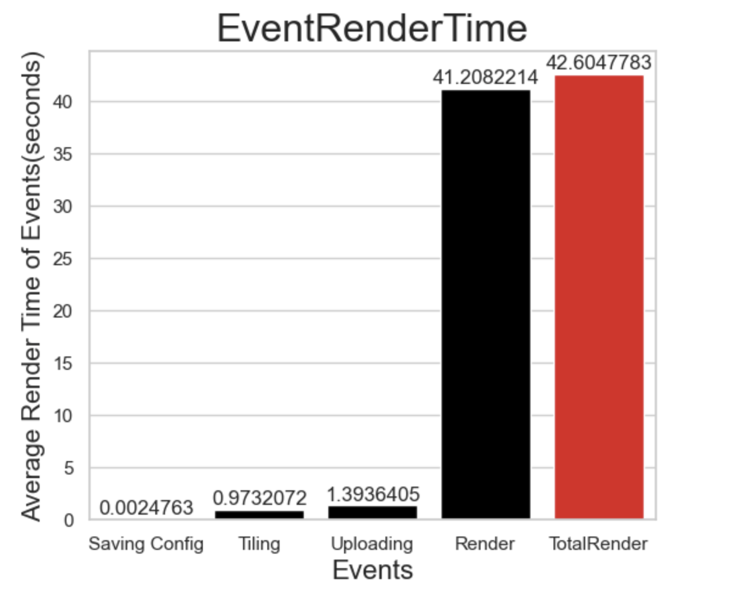

The above bar plot depicts the average render time for all events. The plot shows that **Total Render** takes **42.6047** seconds of render time, which is the average time required to render the entire task. The **Render** event takes the most time, with an average of **41.2082** seconds, followed by **Uploading** and **Tiling**, which take **1.3936** and **0.9732** seconds, respectively. **Saving Config** event takes only **0.00247** seconds, which is the shortest average time when compared to other events.

* + 1. **Correlation between GPU metrics:**

The pair plot above depicts the correlation between all GPU metrics:

* Event_Render Time
* powerDrawWatt
* gpuTempC
* gpuUtilPerc
* gpuMemUtilPerc

GPU utility percentage and GPU memory utility percentage are found to correlate with each other, according to the plot, as GPU utilization keeps increasing with memory utilization. Furthermore, we can deduce that an increase in memory utilization can result in a long event render time. GPU power draw and temperature have the least significant relation. It's also worth noting that render time is inversely related to GPU temperature, so as Event Render time increases, so does GPU temperature.

* + 1. **Identification of serial numbers of GPU with least performance:**

The table that follows lists the unique identifiers of the list of top ten GPUs with the least performance.

The bar plot below depicts GPU card runtime. The GPU card with serial number 2821 has the worst efficiency, with a mean render time of 47.038776 seconds, followed by the GPU card with serial number 8645, which has a render time of 47.013439 seconds. Leaving GPU card ending with serial number 5378 with a 0.020271 second delay in render time from GPU card ending with serial number 5378. Leaving GPU cards 8802 and 1137 with render times of 46.399696 and 46.350880 seconds, respectively, with slightly better performance than the other GPU cards.**Chart, bar chart
**

* + 1. **Interplay between GPU Temperature and Power Consumption:**

The below joint plot shows Interplay between GPU temperature and Power Consumption. It is inferred from the below plot that Power Consumption is directly proportional to GPU temperature as the Power Consumption increased the Temperature of the GPU increases linearly.

The Correlation coefficient between GPU Temperature and Power Consumption = **0.4**

* + 1. **Variation in Memory Utilization Percentage of the GPU with GPU Temperature:**

The scatter plot below depicts the variation in GPU Memory Utilization Percentage with temperature. It depicts two clusters that formed in the same temperature range. When the Memory Utilization Percentage ranges from 28 to 32 and 34 to 37, the GPU temperature varies. There is no linearity between the two. There is no significant relationship between GPU Memory Utilization Percentage and temperature because they are independent of one another.

The Correlation Coefficient between GPU Temperature and Memory Utilization = **-0.18**

* + 1. **Event Render time for each co-ordinate of the Rendered Tile (Level 8):**

The heatmap for Event Render Time for each coordinate of the rendered tile for level 8 is shown above. Shades of green to blue represent tiles with steadily rising event render time, while shades of green represent tiles with average event render time and shades of yellow tiles represent areas with very little time taken for rendering.

1. **Conclusion:**

The following are the conclusions of exploratory data analysis:

* When the event types that dominate task runtimes are examined, it is discovered that the Render event takes the maximum. Reducing the time taken for render event can improve the efficiency in rendering.
* Analysis shows GPU utility percentage and GPU memory utility percentage are linearly proportional to each other.
* The GPU card with serial number 2821 has the lowest efficiency and requires the most render time. Improving GPU performance can aid in reducing rendering time.
* Power consumption is directly proportional to GPU temperature; as power consumption increases, so does GPU temperature.
* There is no significant relationship between GPU Memory Utilization Percentage and temperature because they are independent of one another.
* There is no significant relationship between GPU Memory Utilization Percentage and temperature because they are independent of one another.
* Heatmap pattern for Event Render Time for level 8 helps to focus on Render Time and improve the efficiency in rendering the image.

The observations made above can help and provide insights into ways to improve render time and efficiency in rendering images.

1. **References:**

* <http://www.decisivefacts.nl/2016/08/crisp-dm-process-for-data-mining/?lang=en>
* <https://github.com/NewcastleDataScience/StudentProjects202223/blob/master/TeraScope/Summary.md>

1. **Git Log:**